TITLE OF PAPER
Firstname I. Surname (Corresponding Author)¹, Firstname I. Surname (Co-author)²
¹Affiliation of corresponding author (11pts)
²Affiliation of co-author (11pts)
Email: author1@email.com¹, author2@email.com²

Abstract
This section should contain a concise summary of the paper in 250–300 words. It should provide a clear overview of the study objectives, methods, results, and conclusions. The abstract should be fully justified, single-spaced, and italicized.
Keywords: alphabetically, five, key, maximum, words

INTRODUCTION
Main headings should be centered, bold, and capitalized, using 12 pt Times New Roman font. The main body of the paper should be fully justified, in 12 pt Times New Roman, with 1.15 line spacing. Allow one blank line between major sections such as Introduction, Literature Review, Methodology, Results, Discussion, Conclusion, and References. Do not include page numbers; these will be added by the editorial team.

Second-Level Headings
Second-level headings should be in 12 pt Times New Roman, bold, and left-aligned with title case capitalization. Figures and tables must be numbered separately. Example: Figure 1: Map of Nigeria, Table 1: Frequency data. Table titles should appear above the tables, while figure captions should appear below the figures.
Table 1: Example of Table Format
Sn | Title 1 | Title 2 | Title 3
1
2
3
Source: (Fieldwork, 2017)

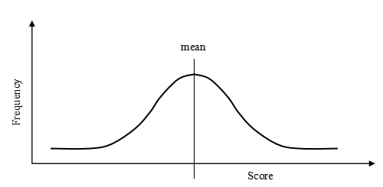
Figure 1: Example of Figure or Plate Format
Source: diagramssite.com (2021)

Third-level heading: Third-level headings should be in 11 pt Times New Roman, italics, and left-aligned with sentence case capitalization.It should be preceded by one blank line, followed by a colon and your text on the same line.
References should be at the end of the paper and should be listed alphabetically. In-text citations and references should be in the APA format (6th or 7th edition). References should be typed in 11 Point Font size. See examples below. Disable all document security and remove any hyperlinks.

REFERENCES
American Psychological Association. (2020). Publication manual of the American Psychological Association (7th ed.). Washington, DC: Author.
Olawale, F. A., & Garwe, D. (2010). Obstacles to the growth of new SMEs in South Africa: A principal component analysis approach. African Journal of Business Management, 4(5), 729–738.
World Health Organization. (2021). Global report on the epidemiology of mental health. Geneva, Switzerland: WHO Press.
Adebayo, T. S. (2019). Renewable energy consumption and environmental quality: Evidence from Nigeria. Energy Reports, 5, 1195–1204.
National Bureau of Statistics. (2020). Annual abstract of statistics. Abuja, Nigeria: NBS.

